Database System: Airline Database Management System

Name: Maha Faisal
- Business Rules:
Purpose: To track flights, keep passenger records, baggage ,to keep track of an employee’s work, airport operations.

Rules:
  - Each airport has multiple terminals while each terminal has multiple gates.
  - Flights operate between airports with specific departure/arrival times.
  - Passengers can book tickets for flights.
  - Employees are either crew (pilots / flight attendants) or ground staff (security, baggage handlers, gate agent).
  - Baggage can be tracked as well through it’s status (checked -> loaded -> delivered/lost).

- Tables:
- Airport:
- Airport_ID (PK)
- Airport_Name
- City
- Country
- IATA_Code

- Terminal:
- Terminal_ID (PK)
- Terminal_Name
- Airport_ID(FK)

- Airline:
- Airline_ID(PK)
- Airline_Name
- IATA_Code

- Airplane:
- Airplane_ID
- Model
- Seat_capacity
- Airline_ID(FK)
- Registration_Number

- Gate:
- Gate_ID(PK)
- Gate_Number
- Terminal_ID(FK)

- Flight:
- Flight_ID(PK)
- Flight_Number
- Departure_Time
- Arrival_Time
- Airline_ID(FK)
- Airplane_ID(FK)
- Departure_Airport_ID(FK)
- Arrival_Airport_ID(FK)

- Passenger:
- Passenger_ID(PK)
- First_Name
- Last_Name
- Passport_Number
- DOB

- Passenger_Phone:
- Phone_ID(PK)
- Phone_Number
- Passenger_ID(PK)

- Ticket:
- Ticket_ID(PK)
- Seat_Number
- Class
- Passenger_ID(FK)
- Flight_ID(FK)
- Price

- Baggage:
- Baggage_ID(PK)
- Passenger_ID
- Weight_KG
- Status_Bag
- Flight_ID(FK)

- Employee:
- Employee_ID(PK)
- First_Name
- Last_Name
- Hire_Date
- Airport_ID(FK)
- Employee_Type

- Crew:
- Employee_ID(PK)(FK)
- Crew_Role
- Airline_ID(FK)

- Ground:
- Employee_ID(PK)(FK)
- Ground_Role
- Gate_ID(FK)

- Relationships:
- Flight and Airport:

A Flight departs from one Departure Airport and arrives at one Arrival Airport.

An Airport can be the departure or arrival point for many Flights.

- Flight and Airline:

An Airline operates one or more Flights.

Each Flight is operated by one Airline.

- Flight and Airplane:

A Flight uses one Airplane.

An Airplane can operate Flights.

- Flight and Baggage:

A Flight can carry many pieces of Baggage.

Each Baggage item is associated with one Flight.

- Passenger and Baggage:

A Passenger can check in multiple Baggage items.

Each Baggage item belongs to one Passenger

- Passenger and Ticket:

A Passenger can buy multiple Tickets.

Each Ticket is bought by one Passenger

Ticket and Flight:

A ticket is for one specific flight.

A flight can have many tickets.

Passenger and Passenger_Phone:

A Passenger can have multiple phone numbers.

Each Phone Number is associated with one Passenger.

Airport and Employee

An Airport employs many Employees.

Each Employee works for one Airport.

Employee and Subtypes (Crew, Ground):

Crew and Ground Staff are specializations of Employee.

Every Crew and Ground Staff member is an Employee

Crew and Airline:

A Crew member is associated with one Airline.

An Airline has many Crew members.

Ground and Gate:

A Ground Staff member is assigned to one Gate.

A Gate may have multiple Ground Staff members

Airport and Terminal:

An Airport has many Terminals.

Each Terminal belongs to one Airport.

Terminal and Gate:

A Terminal has multiple Gates.

Each Gate is part of one Terminal.

SQL:

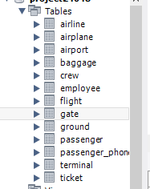
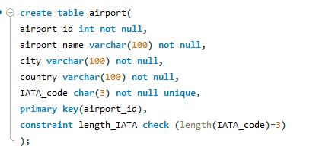
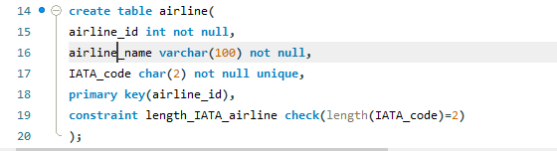
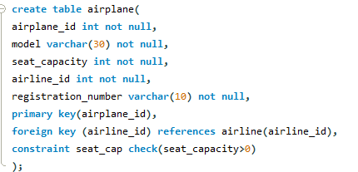
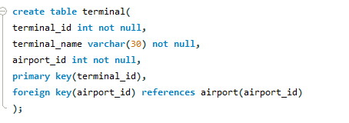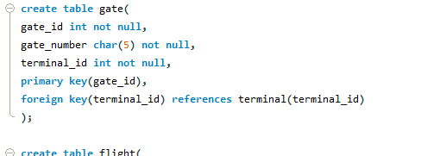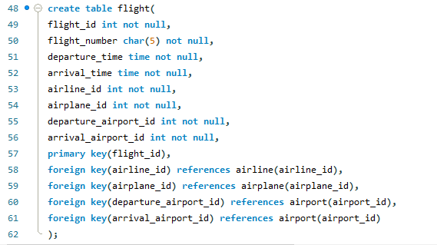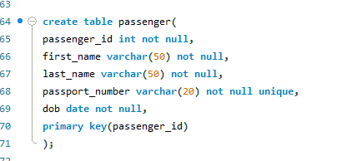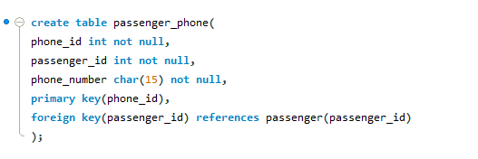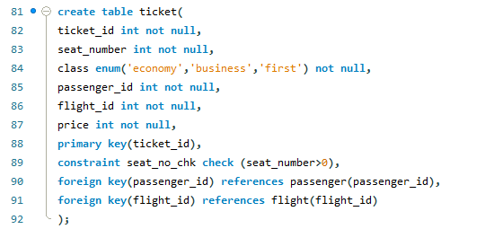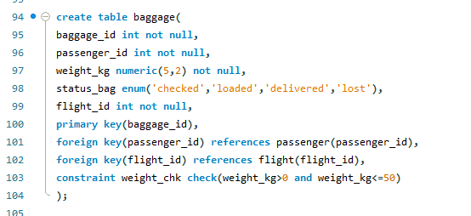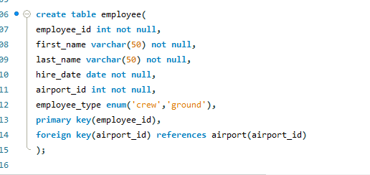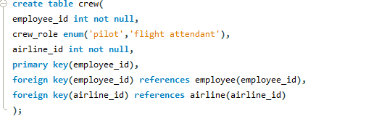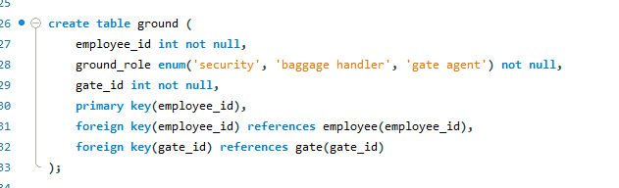

- Inserting Queries:
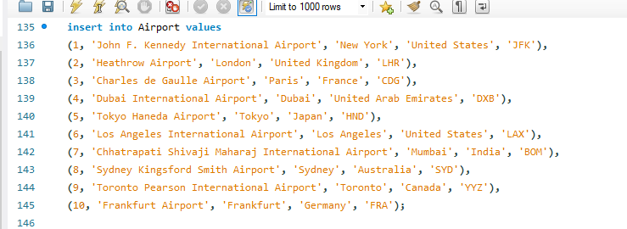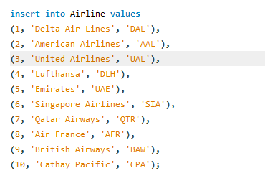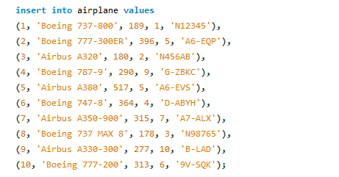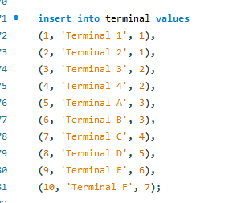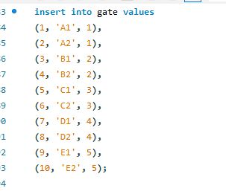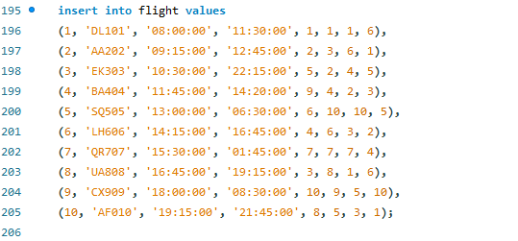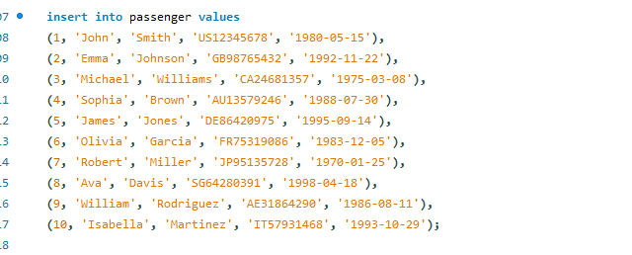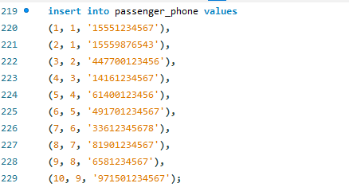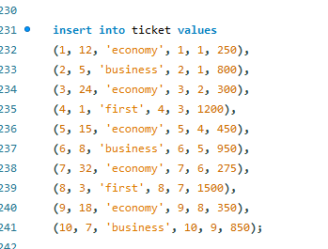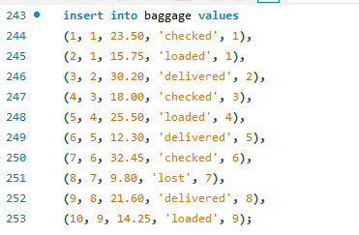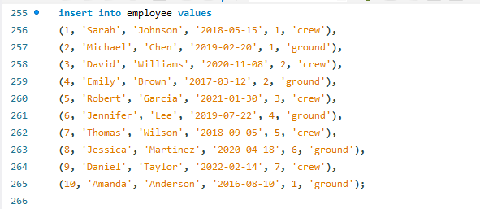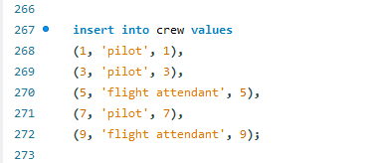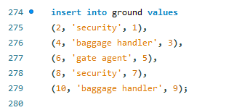

- Select Queries:
- To gain information regarding the departure time and arrival time of all the flights along with the airline names operating the flights.
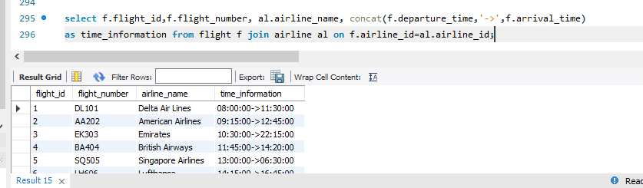
- To gain information regarding number of bags owned by each person.
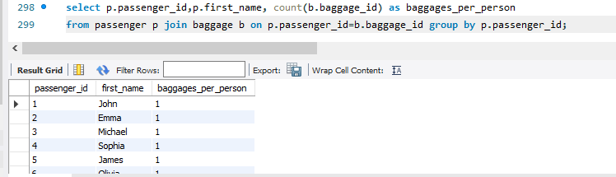
- To check busiest airports on the basis of number of departures taking place.
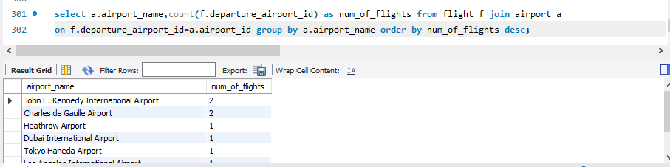
- To check when a pilot’s first license expired or expires.
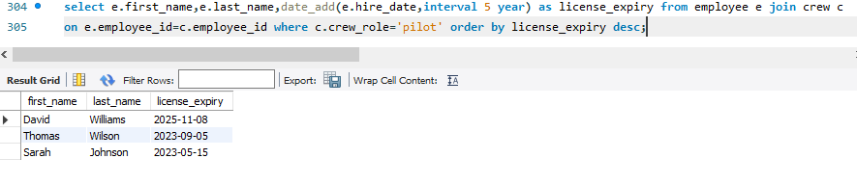
- To gain contact information of each passenger.
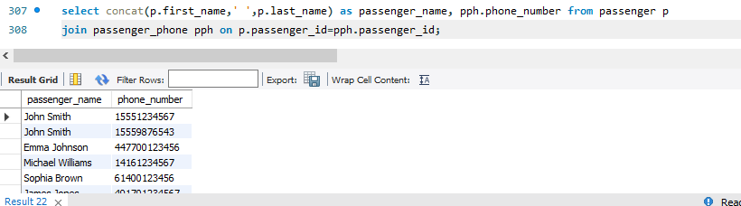
- Passengers with their flights.
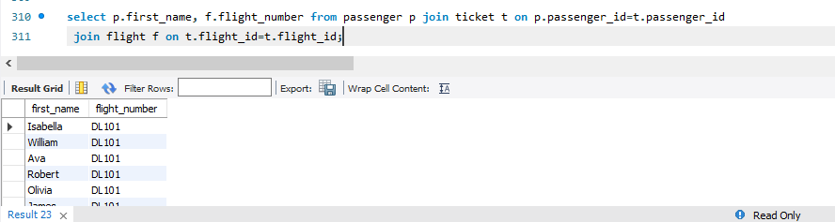
- Airline operating highest number of flights.
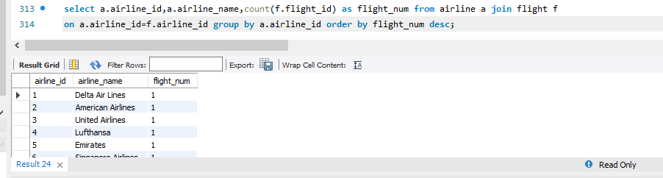
- Seats available for each flight
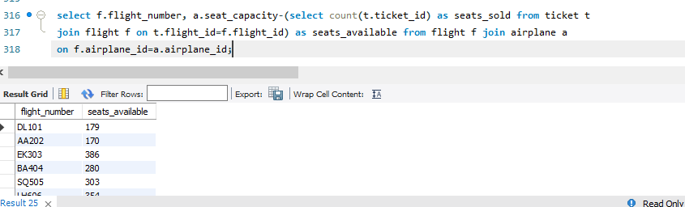
- Order of airports in descending that are busiest on the basis of flights arriving.
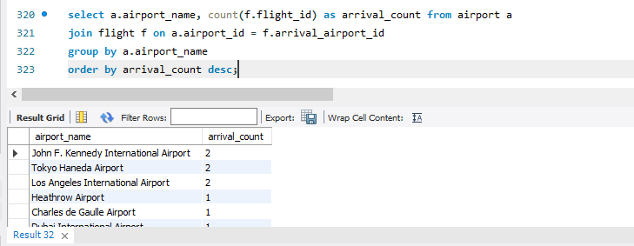
- Crew members and their airlines
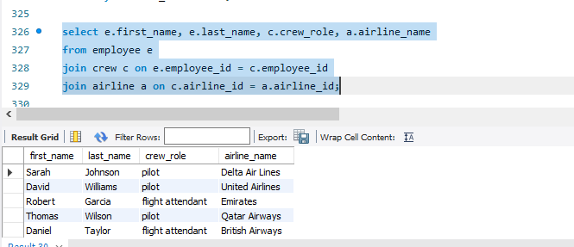

- Number of bags lost of passengers for each flight.
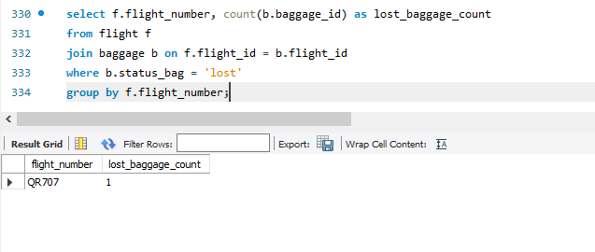
- Ground staff’s terminal name and gate number.
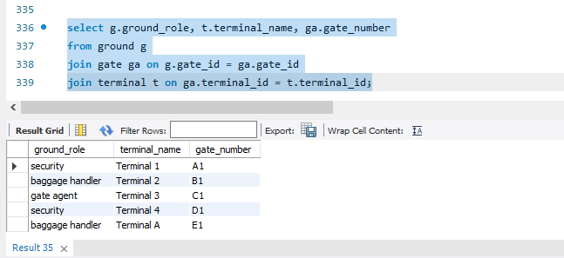
- Number of passengers in each flight
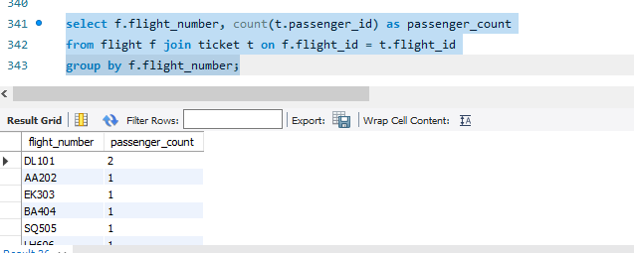
- Average price of tickets varying per class.
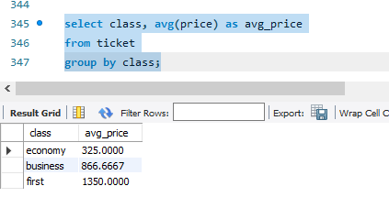
- To gain passengers information present in flight having flight id 1.
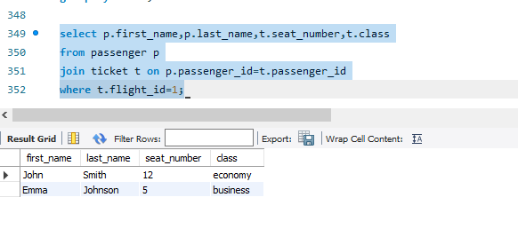
- Update Queries:
- Update status of lost bags to found.
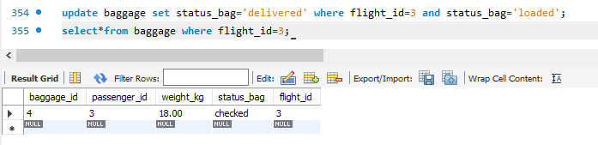
- Updating passenger’s phone number.
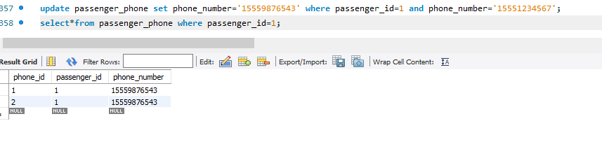
- Increasing the departure and arrival time due to delay.
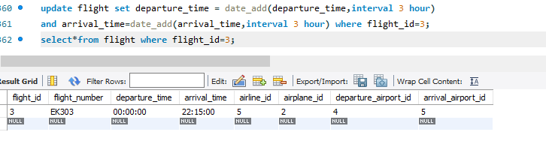
- Mark all baggage as delivered for flight having flight_id=2.
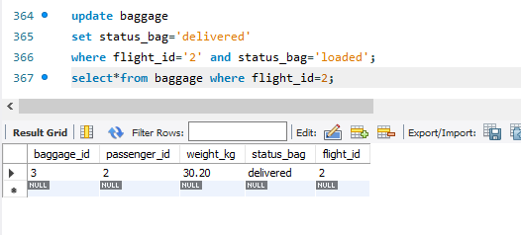
- Change an employee's role
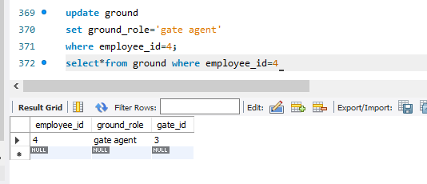
- Updating model of an airplane
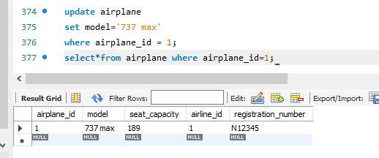
- Correcting passenger’s name
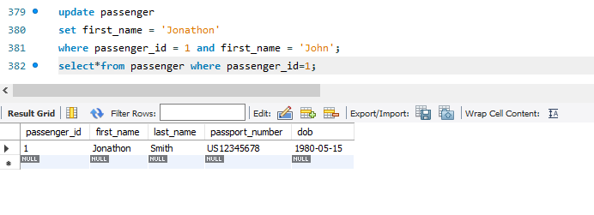
- Updating gate number.
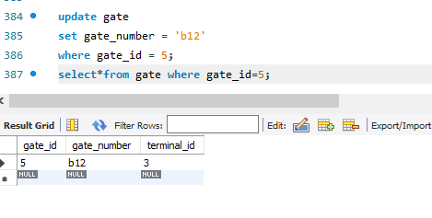

- Updating terminal name for specific airport on basis of iata code.
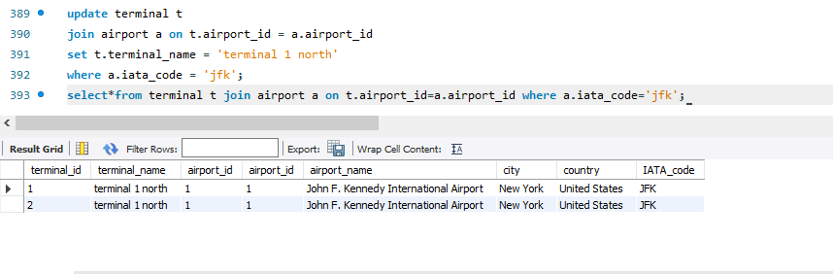
- Updating gate id of a specific ground staff to allocate them different gate.
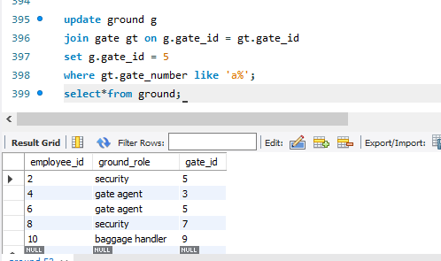
- Delete Queries:
- Deleting from crew employee where employee_id=1;
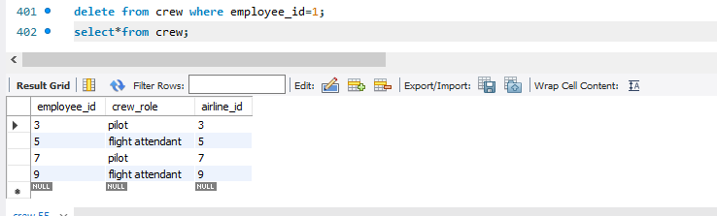
- Deleting ticket for flight id 2.
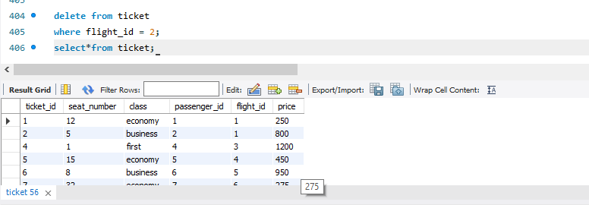
- Deleting employee with id 1.
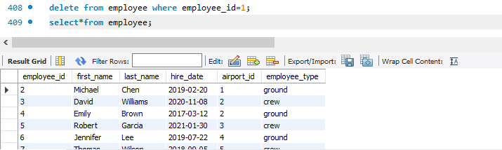
- Deleting baggage who’s weight is 50.
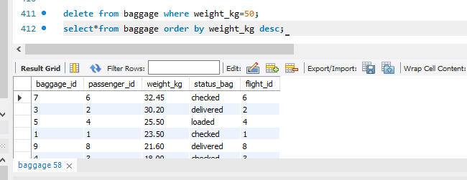
- Deleting passenger’s contact information with id 4.
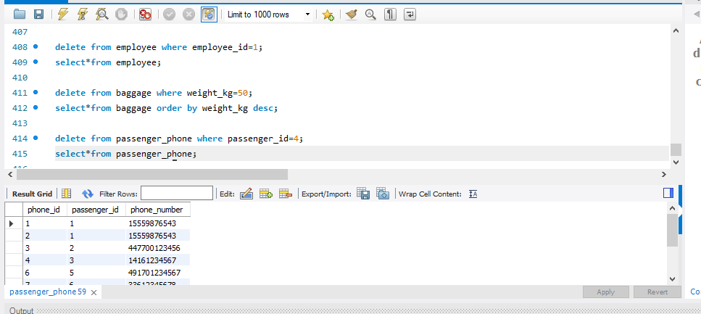
- ERD Diagram:
